CS 255 System Design Document Template

This template lays out all the different sections that you need to complete for Project Two. Each section has guidance to prompt your thinking. You will need to continually reference the interview transcript as you work to make sure that you are addressing your client’s needs. There is no required length for the final document. Instead the goal is to complete each section based on what your client’s needs are. Remove this note when you are finished, and replace all bracketed text with the relevant information.

UML Diagrams

UML Use Case Diagram
[In Module Six, you were asked to complete a use case diagram based on your system design. If you would like to make any adjustments to your diagram, please do so. Please insert your use case diagram here. Check to make sure that you included appropriate components and symbols and that your design meets the client’s needs.]
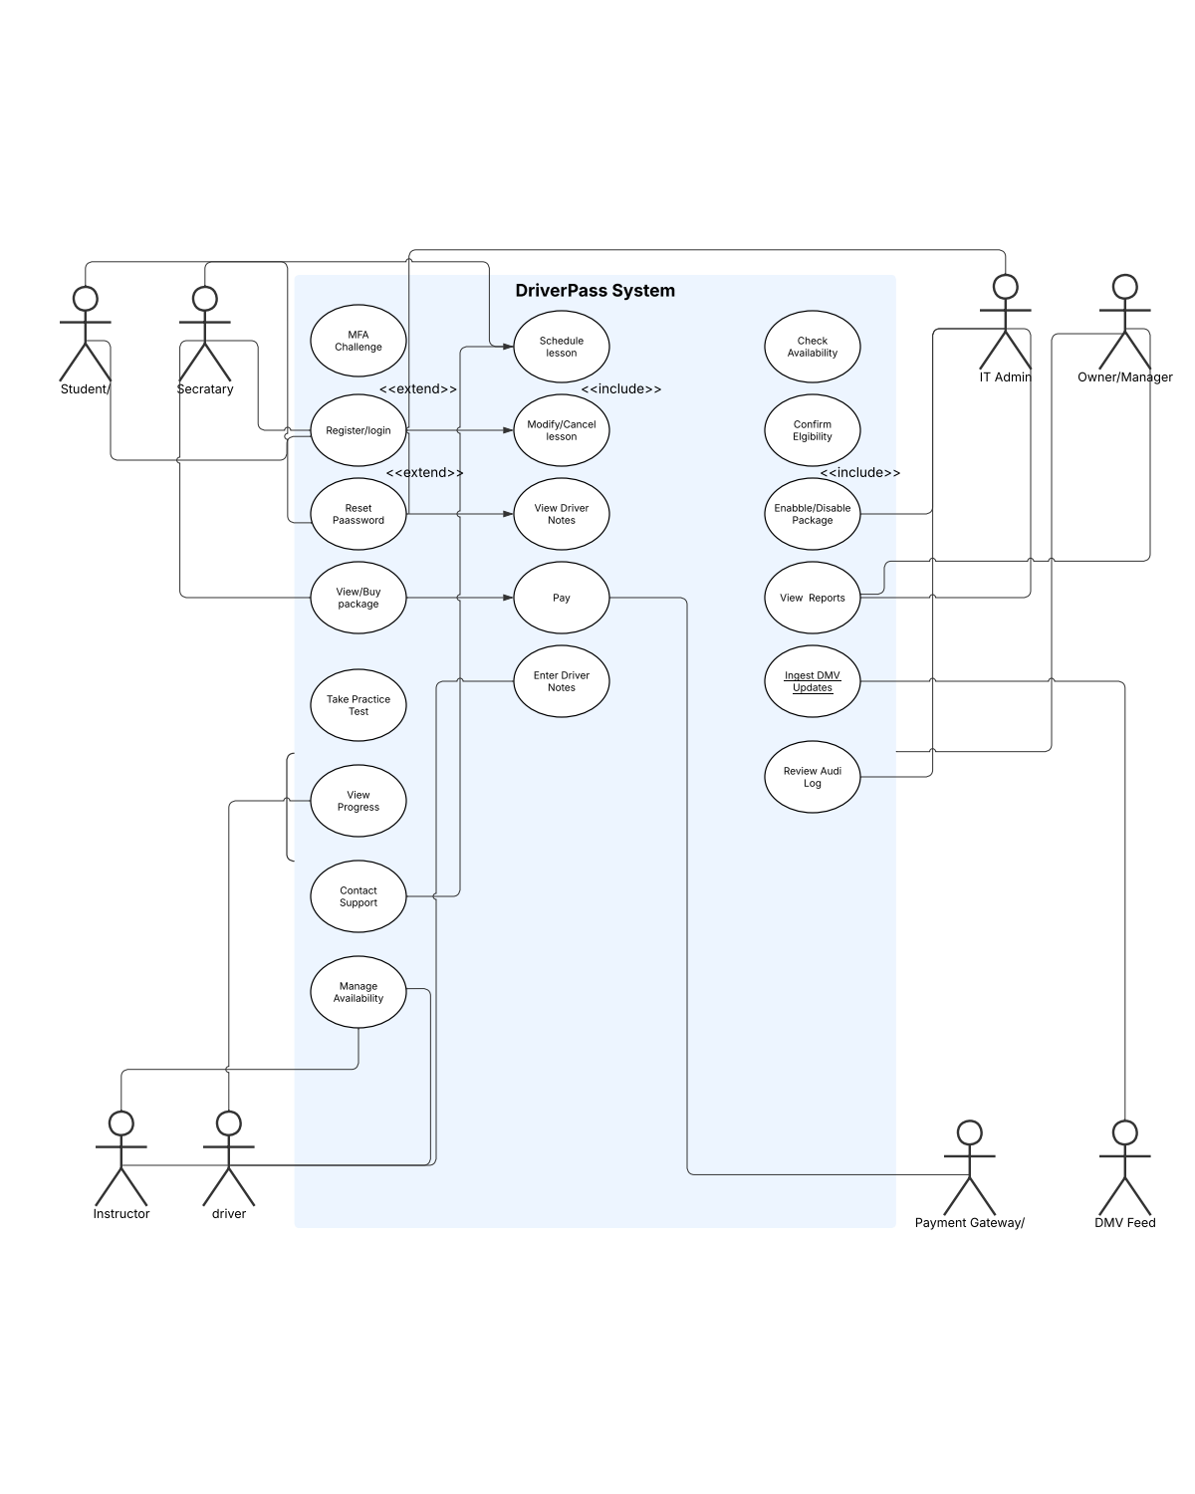

UML Activity Diagrams
[You were asked to choose two use cases and create two activity diagrams, one for each use case. Please insert both of your activity diagrams here. Check to make sure that you included appropriate components and symbols and that your design meets the client’s needs.]

UML Sequence Diagram
[You were asked to create a sequence diagram based on one of the use cases you chose. Please insert your sequence diagram here. Check to make sure that you included appropriate components and symbols and that your design meets the client’s needs.]

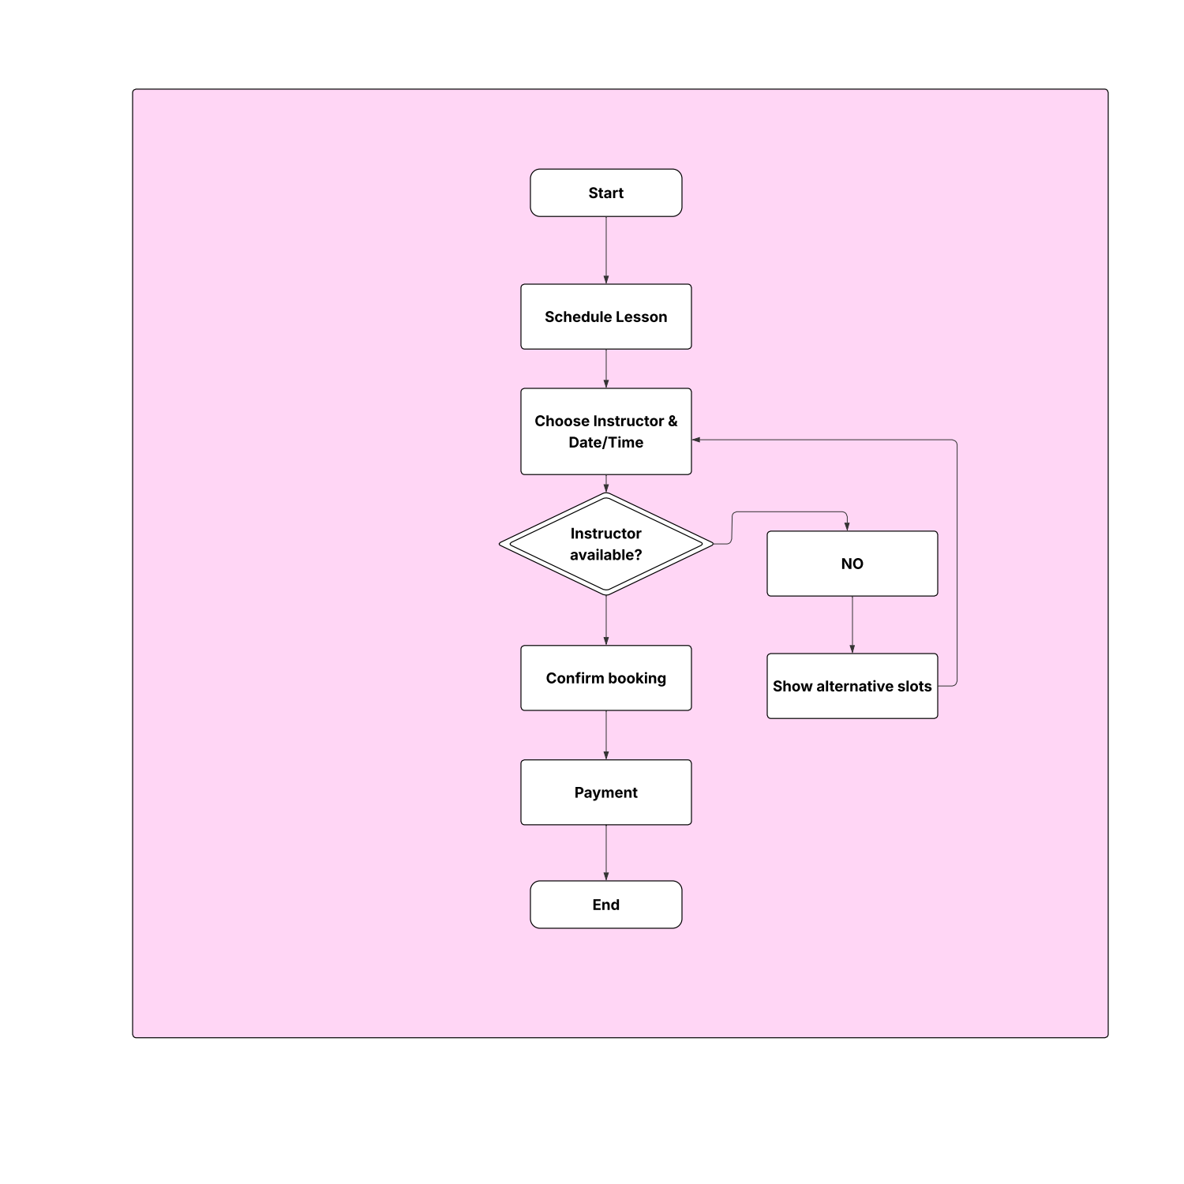

UML Class Diagram
[You were asked to create a class diagram based on the different classes and attributes needed for your system design. You are not required to include methods, but you may if you wish. Please insert your class diagram here. Check to make sure that you included appropriate components and symbols and that your design meets the client’s requirements.]

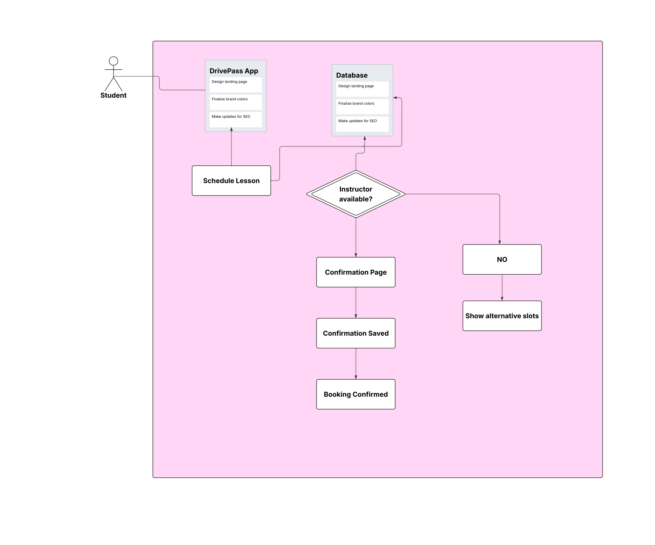

Technical Requirements
[Based on the diagrams you have created, describe the technical requirements of your system. These requirements should address the required hardware, software, tools, and infrastructure necessary for your system design.]

1. Hardware Requirements
- Client Devices:
  - Desktop or laptop computer, smartphone, or tablet.
  - Minimum 4 GB RAM and dual-core processor.
  - Stable internet connection (minimum 5 Mbps).
- Server:
  - Cloud-based or on-premises web server.
  - Minimum 8 GB RAM and quad-core processor.
  - 500 GB storage for user data, lessons, and DMV updates.

2. Software Requirements
- Operating System:
  - Compatible with Windows, mac-OS, iOS, and Android.
- Web Technologies:
  - Frontend: HTML5, CSS3, JavaScript, and React or Angular for user interface.
  - Backend: PHP or Node.js for business logic and server-side scripting.
  - Database: MySQL or PostgreSQL for storing user accounts, packages, and schedules.
- Web Server:
  - Apache or Nginx for hosting the application.
- Version Control:
  - Git and GitHub for source code management.

3. Network and Infrastructure
- Hosting:
  - Deployed on a secure cloud platform (AWS, Azure, or Google Cloud).
- Network Security:
  - HTTPS protocol for data encryption.
  - Multi-Factor Authentication (MFA) for user logins.
  - Role-based access control (Admin, Instructor, Student).

4. Tools and Integration
- Development Tools:
  - Visual Studio Code or IntelliJ IDEA for coding.
  - Postman for API testing.
- Third-Party Integration's:
  - Payment Gateway API (e.g., Stripe or PayPal) for processing student payments.
  - DMV Data Feed API for driving regulation updates.

5. Backup and Maintenance
- Automated daily backups of the database.
- Regular software updates for bug fixes and security patches.
- System monitoring tools to track uptime and performance.

